Interactive Website – Get Baking Documentation

for

Developing Interactive Web Solutions Assignment 011

Prepared by P110112760

COM070

21 December 2022

Table of Contents

1. Introduction 1

1.1 Purpose 1

2. Planning 1

2.1 Mood board 1

2.2 Wireframe 2

2.3 Colour Contrast 3

2.4 Site Map 4

3. Testing 5

Appendix A: References 7

# Introduction

## Purpose

Purpose of this document is to show how Get Baking! Website was planned and what design ideas it had in order to have a fully functional and professional looking website. In this documentation I will cover my planning stage which includes mood board, wireframe and looking into colour contrast to ensure that the website is accessible. And Testing which will show how the website was tested to ensure there is no bugs and it’s fully functional.

# Planning

## Mood board

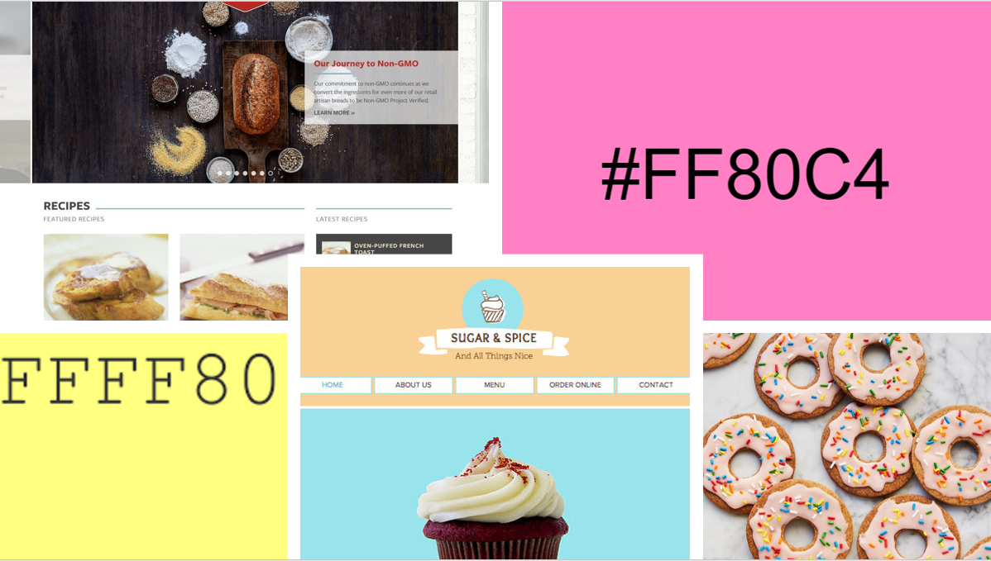It’s important to have a mood board before working on the website, in the research it says that “*They're a valuable resource to help keep the style and aesthetic of a project consistent with a client's goals and expectations*.” (Toptal, n.d.) Which shows that it helps our client to see how we are going to create the website, what inspiration we will have and what to expect for the end result. For this reason, I’ve created a mood board which contained couple of examples of how I think the website should look like and what colour of hex it should be.

(www.wix.comhttps://www.wix.com/website/templates/html/restaurants-food/cafe-bakery, n.d.), (Website Planethttps://www.websiteplanet.com/blog/20-inspiring-bakery-websites/, 2019)

(Jan. 9 and 2021, 2021)

## Wireframe

Wireframe provides us great example of how we will create our website, this means by showing by planning components in a specific location, for example where we want our navigation bar to be or where we want our titles to appear. For that reason, I’ve drawn my Wireframe to have a rough idea of how I will be creating the website, and this can be seen in the image below.

This Wireframe shows that the website will be made on a single page, all important information is marked by showing where components should be placed at to make it easily accessible. Navigation bar will have a text logo and 3 different buttons for scrolling to a specific section of the website. For example, H (Navigation Bar) would go the Title 1 section. It also shows where is logo located at, where recipes will be shown and where there will be a form for users to fill in if they want to share their recipe.

## Colour Contrast

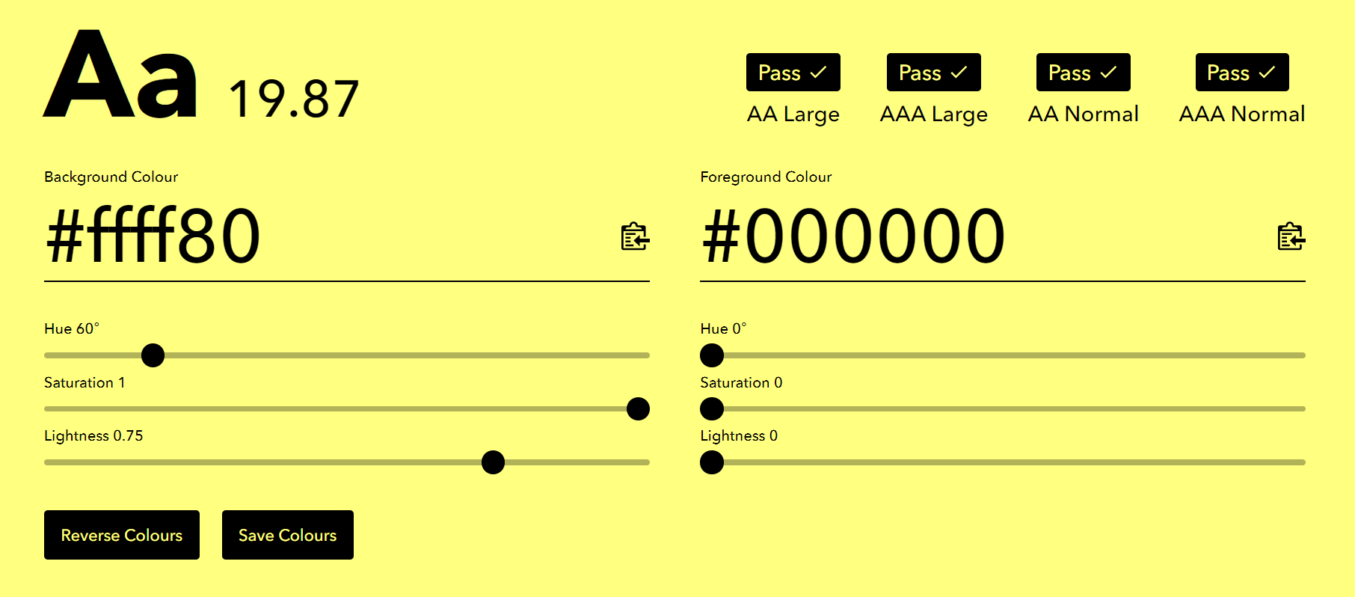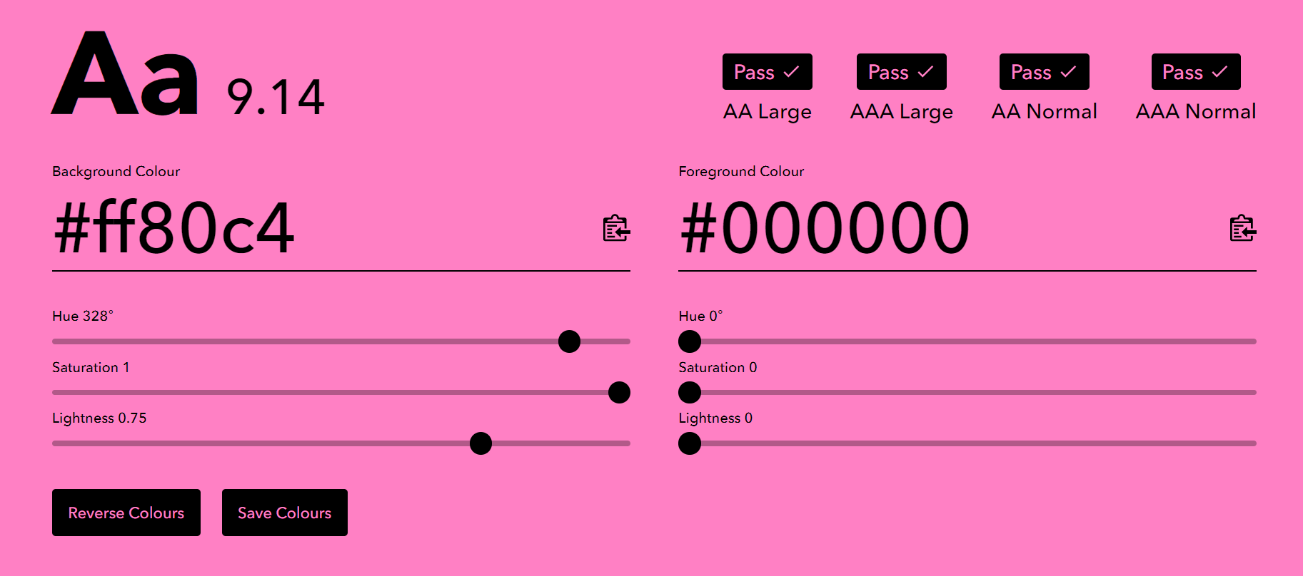It’s extremely important to look into colour contrast, as our customer wants the main colour scheme for Get Baking website to be #ff80c4 and #ffff80, which can be hard to read for some users, for that reason I’ve used Colour Contrast website to identify which colours are accessible for everyone. For that reason, I’ve chosen black (#000000) to be main colour for text and shadows, this is because black goes along with both main colour schemes and it’s readable by everyone and passes all tests for colour contrast. This can be seen in the images below.

These images both provide information that our colour for text will go along with wanted main colour scheme, as it passed all tests which are shown on the top right corner of the images. For that reason I’ll be using black as text or shadow colour to make it visible for everyone.

## Site Map

Site maps provide information on how to navigate through the page and where to find specific information. This can be done by having a diagram consisting of different components of the website and what information they hold, and it’s great to have this for planning as it helps to create components for the website and ensure it shows needed information. The diagram below shows a site map used for navigating throughout the website.

# Testing

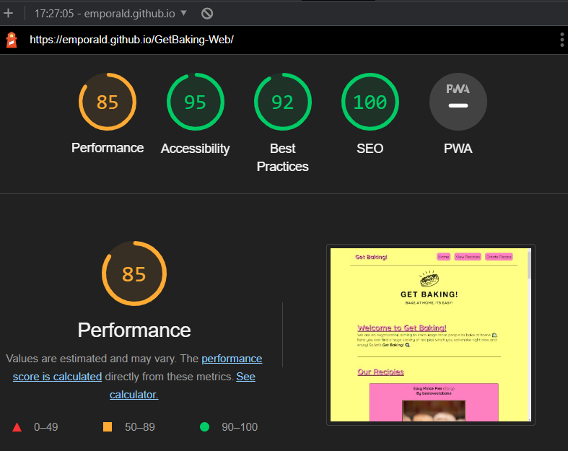It’s extremely important to test the website to ensure that it’s bug-free and shows information which is needed. To fully test out the website after creating it, there is 2 tools which help to identify issues and fix them. Firstly, it’s extremely useful to do testing with google implemented tool called Lighthouse, which helps to identify issues and how they can be improved in order to have a faster and more professional website, after running Lighthouse for Desktop and Mobile view there was couple of issues which were identified and fixed such as ensuring that images are in .webp format and are appropriate size which greatly increases speed of loading pages. The image below shows desktop lighthouse test.

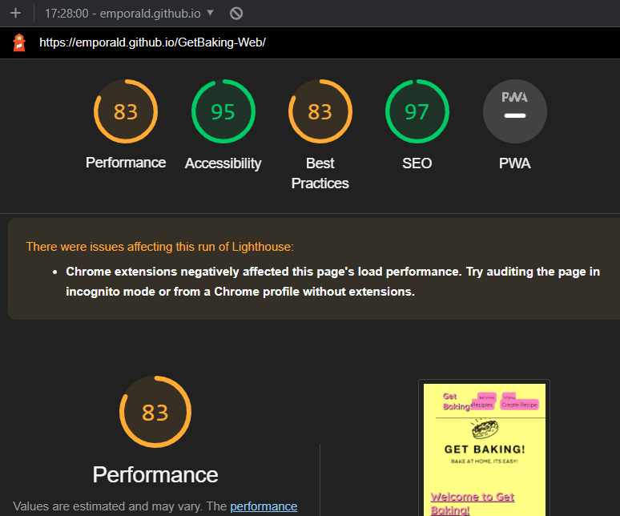This test shows that our accessibility, best practises, and SEO are in extremely good condition, and were executed properly to maximize performance of our website, but the Performance tab falls below, this is due to using API which is only supporting the .png images and they had to be resized within the CSS language, it could be easily fixed in the future to ensure that our website is running faster in the desktop view. Second image below will be our mobile view.

There were more issues with the mobile view, which decreases performance and best practises which could be improved on to ensure that the website if running more smoothly and there is no unneeded errors.

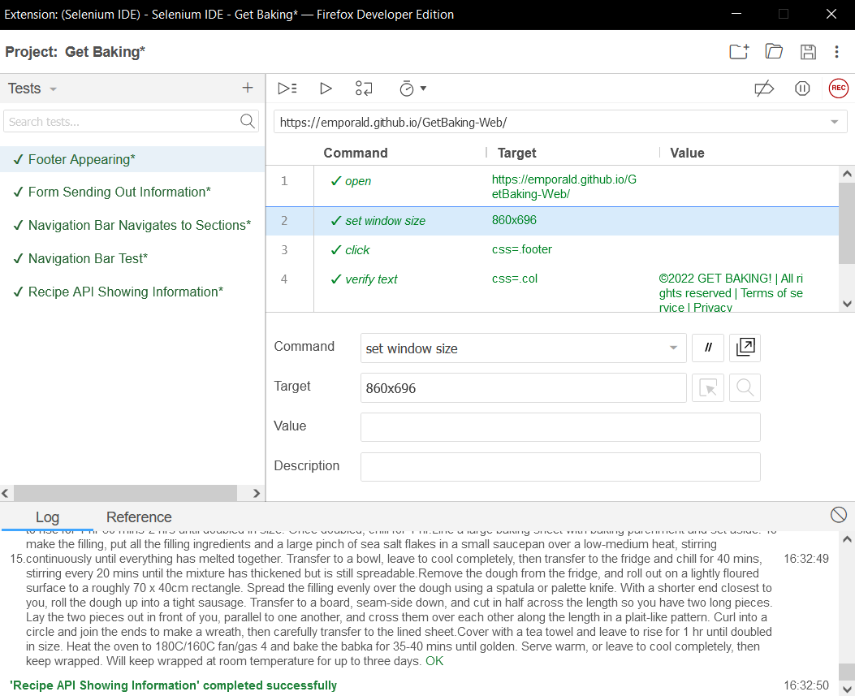Lastly, it’s important to use another tool called Selenium UI which is a browser extension to test out if your website loads content and if there are any speed issues. For this reason, I’ve did couple of tests on the website to see if all information is displayed to the user and if the navigation bars of the website work as intended. The image below shows different tests which were executed and provided information that our website is working as intended and there were no issues with loading content and navigating throughout the website.

# Appendix A: References

Jan. 9, T. P. | and 2021 (2021) 67 Fun Things to Bake When You’re Bored and Craving Something Sweet [Online]. Available at https://www.purewow.com/food/fun-things-to-bake (Accessed 21 December 2022).

Toptal (n.d.) Use Your Inspiration – A Guide to Mood Boards [Online]. Available at https://www.toptal.com/designers/visual-identity/guide-to-mood-boards#:~:text=Mood%20boards%20serve%20many%20purposes (Accessed 21 December 2022).

Website Planethttps://www.websiteplanet.com/blog/20-inspiring-bakery-websites/ (2019) 20 Best Bakery Websites – Web Design Inspiration 2021 [Online]. (Accessed 21 December 2022).

www.wix.comhttps://www.wix.com/website/templates/html/restaurants-food/cafe-bakery (n.d.) Cafe & Bakery Website Templates | Restaurants & Food | Wix.com [Online]. (Accessed 21 December 2022).